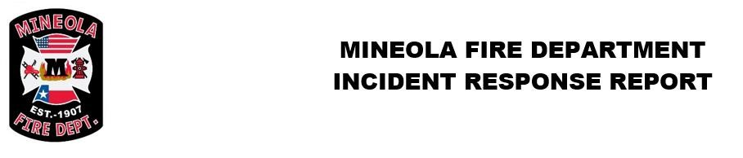
Incident Reports By Incident Type, Summary October 2018
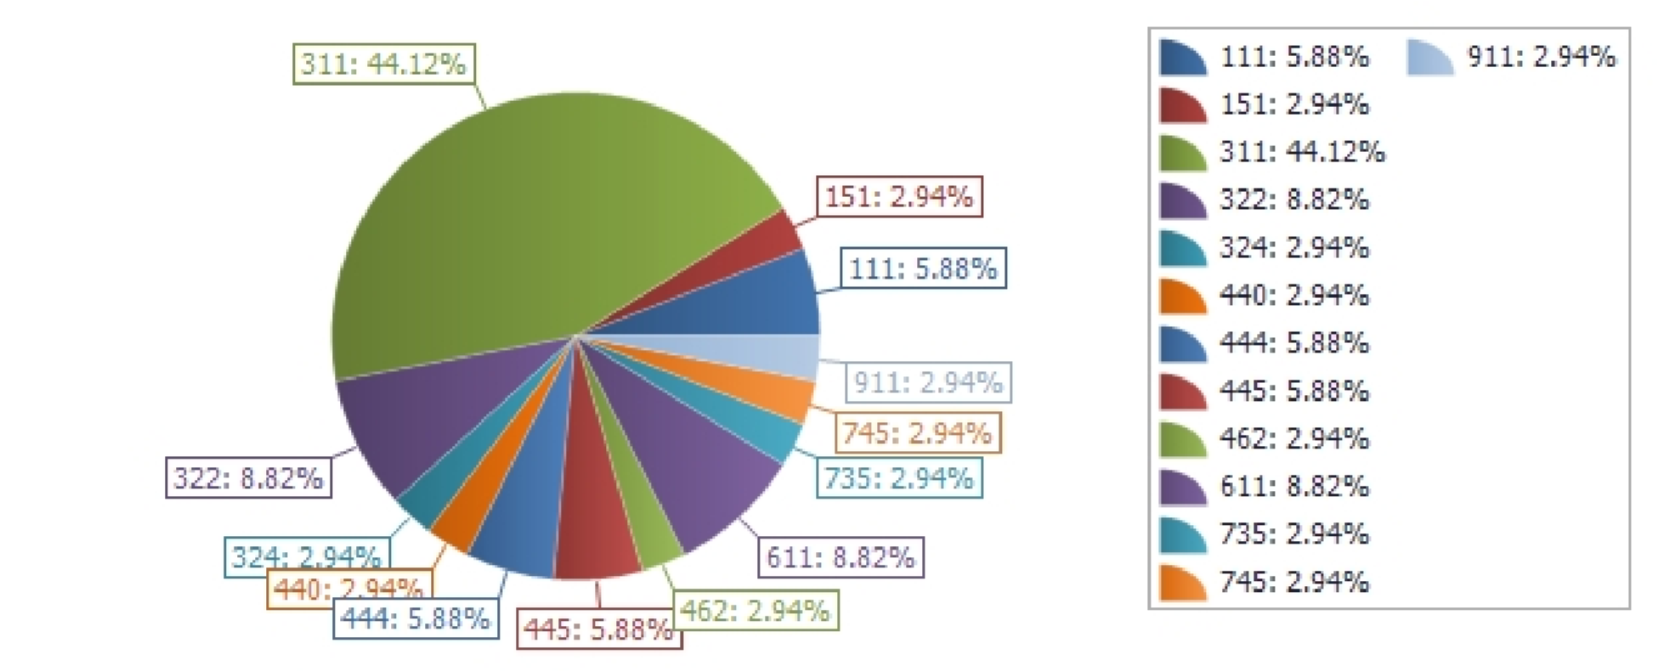
Incident Type Total Incidents Percent

111 - Building fire
151 - Outside rubbish, trash or waste fire
311 - Medical assist, assist EMS crew 322 - Motor vehicle accident with juries
324 - Motor vehicle accident with no injuries.
440 - Electrical wiring/equipment problem, other
- - Power line down
- - Arcing, shorted electrical equipment
462 - Aircraft standby
611 - Dispatched & canceled en route
735 - Alarm system sounded due to malfunction
745 - Alarm system activation, no fire - unintentional
911 - Citizen complaint
Total Number of Incidents: Total Number of Incident Types:
November 05, 2018 09:10
2
1
15
3
1
1
2
2
1
3
1
1
1
34
13
5.88%
2.94
44.12%
8.82
2.94
2.94
5.88
5.88
2.94
8.82
2.94
2.94
2.94
Page 1 of 2
Performed fire prevention programs for approximately 300 kids. Also assisted Alba FD with programs for Alba Golden ISD.
November 05, 2018 09:10 Page 2 of 2

